***Experiment 4***

***Preparation and Properties of Oxygen***

***OBJECTIVES***

The objectives of this experiment are: (a) to prepare oxygen from hydrogen peroxide, (b) to experience the preparation and use of a catalyst, (c) to write chemical equations, and (d) to observe the effect of concentration on the rate of reaction.

***INTRODUCTION***

Oxygen is the most abundant element in the earth's crust and the human body. Oxygen exists in the earth's crust exclusively combined with other elements, primarily with silicon and aluminum. It is also abundant in the atmosphere, comprising approximately 21% of the air volume. Oxygen exists in the air primarily in elemental form as diatomic molecules (O2). It also exists in combination with carbon, as carbon dioxide (CO2), and with nitrogen, as nitrogen oxides.

Not only is oxygen a very abundant element, it is also essential for life. In elemental form, oxygen is needed for respiration in all animals and plants and is necessary for the combustion of all fuels. Its compounds, which are large in number, are also of great importance. Among these are water, carbon dioxide, sulfuric acid, nitric acid, sodium hydroxide, organic acids, aldehydes, ketones, proteins, and carbohydrates.

Oxygen was first isolated in pure form in 1774 by **Joseph Priestly** and **Carl Wilhelm Scheele**. Priestly accomplished this by heating mercury(II) oxide, (HgO) which decomposes upon heating to mercury metal and oxygen gas.

In this experiment, you will prepare pure oxygen by another method and investigate some of its properties. The method of preparation involves the decomposition of hydrogen peroxide (H2O2). This compound is inherently unstable, decomposing to oxygen and water according to the equation:

2H2O2 🡪 2H2O + O2

The reaction is very slow; however, there are many catalysts which will speed up the reaction so as to make it useful for the preparation of oxygen. Among those are potassium iodide, copper(II) chloride, manganese(IV) oxide and more. Enzymes in living systems, such as peroxidase and catalase found in blood, can also catalyze the decomposition of hydrogen peroxide. The one you will use is a copper(lI) complex ion, [Cu(NH3)4]2+ .

EXPERIMENTAL PROCEDURE

1. ***Catalytic Decomposition of Hydrogen Peroxide:***

Set up the apparatus shown in Figure 1 below. [***Instructors:*** *clamp a 500 mL Florence flask to a ring stand. Insert a thistle tube in a two-hole rubber stopper, which fits the flask. The end of the thistle tube should be about 1 cm above the bottom of the flask when the stopper is in place. Carefully insert a bent glass tube into the other hole of the stopper. Connect a ~50 cm piece of rubber tubing to the outlet end of the glass tube*].

Place the rubber stopper containing the thistle tube and glass tube into the mouth of the flask. Connect the other end of the rubber tubing to the outlet underneath the trough. Fill a pneumatic trough with water about half way.

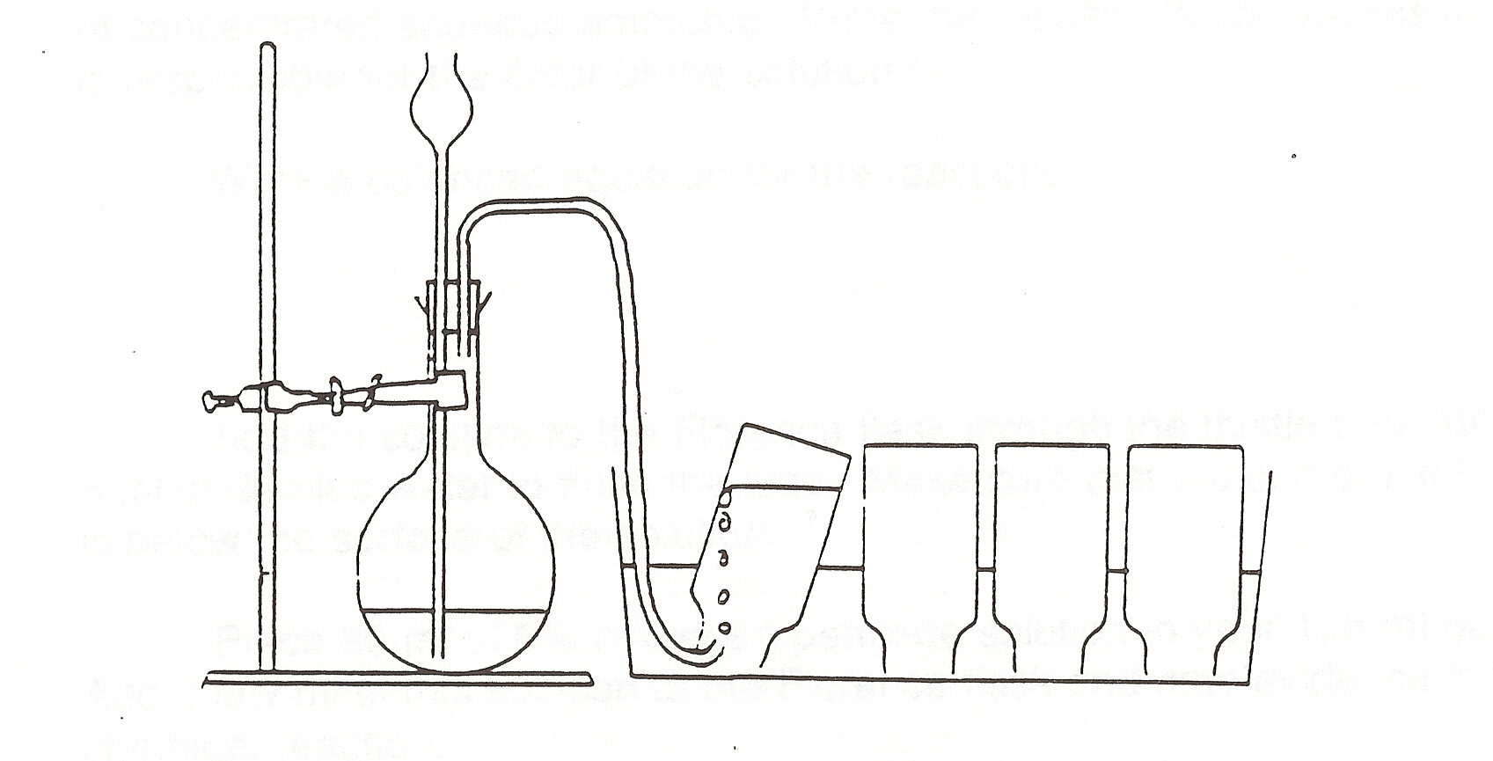

Figure 1. Apparatus for generating oxygen from H2O2

In a 100 mL beaker, place 10 mL of copper(II) sulfate solution, CuSO4, followed by 5 mL of concentrated aqueous ammonia (**ammonia should be handled under fume hood**).

*Question 1: Note the result.*

***The solutions becomes dark blue. (2pnt)***

*Question 2: What color is copper(II) sulfate?*

***Sky blue if diluted. (1pnt)***

*Question 3: What color is the ammonia?*

***Clear. (1pnt)***

*Question 4: What is the product that is responsible for the deep blue color of the solution?*

***Cu(NH3)42+  (2pnt)***

*Question 5: Write a balanced equation for the reaction that occurred. (Unbalanced equations can be found on page 6 of the lab).*

***Cu2+  + 4NH32+  🡪 Cu(NH3)42+  (2pnt)***

Add the solution to the Florence flask through the thistle tube, followed by 5 mL of distilled water to rinse the tube. Make sure that the end of the thistle tube is below the surface of the solution; if not, you might add distilled water to reach that point or consult with you instructor.

Fill three wide mouth bottles with water and place a glass plate over the mouth of each bottle, making sure that there are no air bubbles in the bottles. Invert the bottles in the pneumatic trough. *Your instructor will demonstrate the proper way of doing this part.* (If not enough bottles are available, do two bottles at a time).

Move one of the bottles over the outlet of the trough. Make sure the bottle is still holding the water!

Place 25 mL of 6% hydrogen peroxide solution in a 100 mL beaker. Add **a few** mL of this solution to the Florence flask.

*Question 4: Note evidence of any chemical reaction.*

***Great deal of bubbles. (1pnt)***

*Question 5: Write a balanced equation for the reaction that occurred.*

***2H2O2 🡪 2H2O + O2 (2pnt)***

**Slowly** add the more of the remaining hydrogen peroxide solution so that the water is slowly displaced from the bottle in which the gas is being collected. When the bottle is almost filled with gas, cover the mouth of the bottle with a glass plate under the surface of the water and set the bottle upright on the laboratory bench. **It is recommended to leave a small amount of water enough to cover the bottom of the bottle.** Fill the other **two** bottles with oxygen gas by following the same technique. Keep them in order.

1. ***Properties of Oxygen:***

*Question 1: List two physical properties of oxygen.*

***Gas, no color, no odor, … (2pnt)***

***2.1. Reaction of Oxygen with Nonmetals (Carbon):***

Take a small piece of copper wire (~10 inches long) and wrap one end of it around a small piece of charcoal (pea size). Heat the charcoal in a Bunsen burner flame until it glows. Remove the glass plate from the **second** bottle and quickly insert the glowing charcoal into the bottle using the wire as a handle.

*Question 2: Record your observations and interpret the results.*

***It glows brightly. (1pnt)***

*Question 3: Write a balanced equation for the reaction that occurred.*

***C + O2 🡪 CO2 (2pnt)***

Repeat the process using the **first** bottle of oxygen.

*Question 4: Account for any difference in your observation between the two bottles.*

***It glows, but not as bright. The oxygen in the second bottle is more pure, since the first bottle has collected the air that was originally in the system. (1pnt)***

***2.2. Reactions of Oxygen with Metals (Iron):***

Wrap one end of the piece of copper wire from above around a small wad of steel wool. Using the other end of the wire as a handle, heat the steel wool in a Bunsen burner flame until the steel wool glows. Remove the glass plate from the **third** oxygen bottle and quickly insert the steel wool in the bottle.

*Question 5: Record the results, including the appearance of the steel wool after the reaction.*

***It glows brightly. (1pnt)***

*Question 6: Write a balanced equation for the reaction that occurred.*

***Fe + O2 🡪 Fe2O3 (red)***

***Fe + O2 🡪 Fe3O4 (black) (2pnt)***

=====================================================

***Unbalanced Chemical Equations for the Reactions that Occurred.***

H2O2 🡪 H2O + O2

Fe + O2 🡪 Fe2O3 (red)

Fe + O2 🡪 Fe3O4 (black)

C + O2 🡪 CO2

Cu2+ + NH3 🡪 Cu(NH3)42+